OBJECTIVE:

This analysis aims to provide a comprehensive understanding of pizza sales, including top selling products, sales trends ,areas for improvement , enhance customer satisfaction and loyalty and to support strategic planning and decision-making.

DATA COLLECTION:

For this project ,to perform sales analysis I gathered relevant datasets from Kaggle,a popular online platform for datasets used in datascience and analytics projects. After exploring more datasets, I selected Pizza sales dataset in which where I can perform sales trends and patterns.I downloaded the dataset in CSV format and imported to Excel sheet for intial review and then I imported to Power BI for further steps.

DATA CLEANING:

After importing to the Power BI, I transformed into the power query editor. As the dataset I taken was almost cleaned and done only few steps as follows

Promoted first row as header and checked datatypes of all columns are in correct format.

In Pizza-size column replaced S, M, L, XL with Small, Medium, Large, XLarge respectively.

Changed order- date format from 01 January 2015 to 01-01-2015.

DATA ANALYSIS:

Some DAX measures and calculated columns are done that which are used for analysis and visualizing for the reports.

Measures:

Total sales: sum(pizza_sales[total_price])

Total no of orders = DISTINCTCOUNT(pizza_sales[order_id])

Average pizzas per order = divide([Total Pizzas sold],[Total no of orders])

Total Pizzas sold = sum(pizza_sales[quantity])

Target = pizza_sales[Total sales]*1.5

Calculated Columns:

Day of Week = format(pizza_sales[order_date],"dddd")

Month = format(pizza_sales[order_date],"MMMM")

Order Hour = format(pizza_sales[order_time],"HH AM/PM")

DATA VISUALISATIONS:

1. KPI Cards: Used Card visuals for Total Sales, Total Orders, Avg Pizza per order , Total Pizzas, Count of Pizzas and Target.
2. Trend Line: Line chart with Order Month on X and Total Sales measure on Y.
3. Top Pizzas: Funnel Chartwith pizza_name and Pizza Revenue, sorted Top 10.
4. Size & Category Breakdown: Bar chart and pie charts over pizza_size and pizza_category.
5. Hourly Heatmap: Matrix visual table with Order Hour vs pizza_size showing count.
6. Sales by order date: Donut visual of sales over Order date hierarchy.

Added Slicers Drag slicers for pizza_category, button slicer for pizza_size, and a date slicer (between/hierarchy) for order_date.

Therefore, by using above cards and visuals and inserted some pictures from my desktop and prepared DASHBOARD as follows

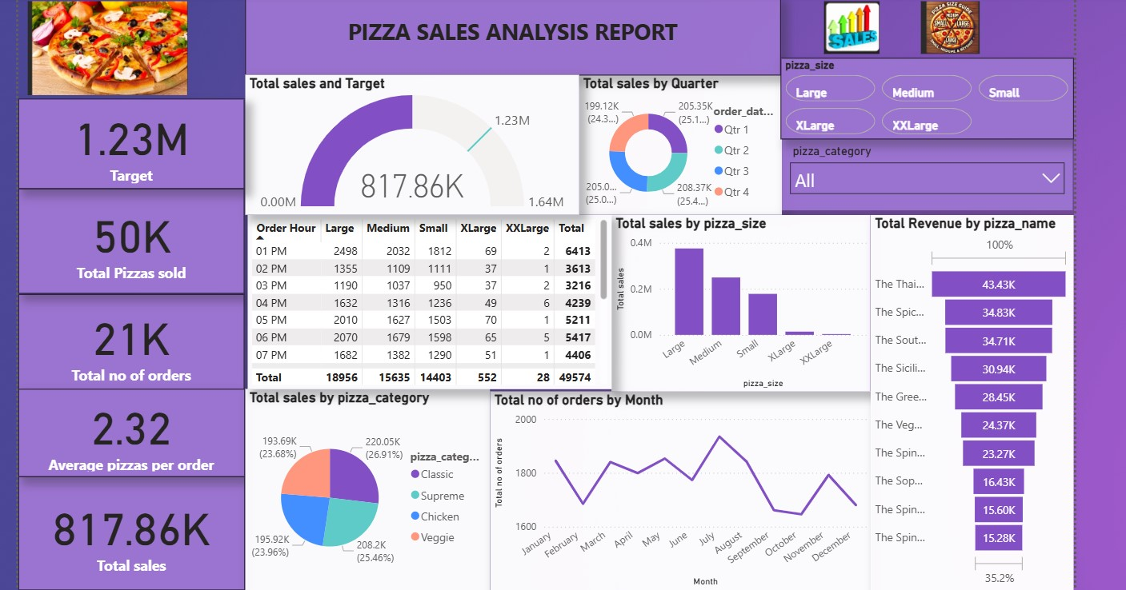

INSIGHTS AND FINDINGS:

1. Top-Selling Pizzas: The top three best-selling pizzas are Thai Chicken Pizza, The Spicy Italian Pizza,The South-West Chicken Pizza accounting for 60% of total sales.

2. Sales Trends: Sales peak on Fridays and Saturdays, with a significant drop on Mondays and Tuesdays.

3. Classic Pizza Sales: Classic pizzas contribute 27% to total sales, with the Classic Greek pizza being the top-selling classic variety.

4. Chicken Pizza Sales: Chicken pizzas sell the most on Fridays, with a 25% increase in sales compared to other days.

5. Slow-Moving Pizzas: The Spinach pesto pizza has the lowest sales, accounting for only 5% of total sales.

6.Peak Hour Sales: During Lunch time that is from 12 pm to 1 pm orders are more when compared to remaining hours in a day.

Recommendations:

1. Promote Spinach Pesto Pizza: Since spinach pesto pizza has the lowest sales, consider offering promotions or discounts to boost its popularity. This could include bundling it with other menu items, offering a "pizza of the month" deal or any

2. Optimize Lunch Hour Operations: As the peak hour sales during lunch time (12 pm - 1 pm), ensure that there will be well-staffed and equipped to handle the increased demand during this period. Consider offering special lunch deals or limited-time offers to capitalize on this busy period.

3. Analyze Sales Data: Regularly review sales data to identify trends and patterns in customer preferences. This will help you make informed decisions about menu offerings, pricing, and marketing strategies.

4. Enhance Customer Experience: Focus on providing excellent customer service and an enjoyable dining experience to encourage repeat business and positive word-of-mouth.

5. Monitor and Adjust: Continuously monitor sales data and customer feedback to adjust your strategies as needed.

Conclusion:

By optimizing operations and promoting underperforming products, the restaurant can increase sales and customer satisfaction. Continuous monitoring and analysis will help drive business growth and improvement. Effective strategies will lead to enhanced performance and competitiveness.

Prepared by:

LALITHA T

Top of Form

Bottom of Form